

CS-221: Data Structures and Algorithms Semester Project

Deliverable #4: Final Project Submission (07/12/25)

Course Instructor: Dr. Zubair Ahmad

Group Members:

- Abdul Raffay Gill (2024019)
- Syeda Maheen Kazmi (2024627)
- Youraj Ali Karim (2024666)

Repository Link: https://github.com/syedamaheenkazmi172/Blockchain_implementation_using_DSA.git

Mini Implementation of Blockchain Using Data Structures and Algorithms
- Project overview:
A blockchain is a decentralized, immutable ledger that maintains a chronological chain of blocks, each containing transaction data, cryptographic hashes, and references to previous blocks. Each block is secured through proof-of-work mechanisms where miners compete to validate transactions by solving computational problems. Once a block is mined and added to the chain, its integrity is guaranteed through cryptographic linking—modifying any historical block would break the chain's integrity. This technology enables trustless, transparent systems where multiple parties can transact without a central authority, making blockchain the backbone of cryptocurrencies and distributed systems.
Our blockchain simulation project resonates with these core principles by creating a functional model where users can initiate transactions, miners validate and mine pending blocks, and the system maintains an immutable record of all mined transactions. Users authenticate using private keys (derived from their usernames using bitset encoding), create transactions that specify recipient wallet addresses and amounts, and these transactions enter a pending queue ordered by transaction fees. Miners then select transactions from this queue, perform computational work to generate valid hashes through iterative nonce-to-hash conversion, and upon successful mining, earn rewards (20% of transaction fees) while the mined block becomes part of the permanent blockchain.
- Implemented data structures and algorithms
Following data structures are implemented in our project:
- Linked List:
The project uses a custom doubly linked list structure to manage blocks. Each block contains both next and prev pointers, enabling bidirectional traversal. This structure is essential for the blockchain, as it allows efficient insertion, deletion, and traversal of blocks in both directions. The Block struct includes these pointers, and the BlockChain class maintains head and tail pointers to manage the chain. The doubly linked list ensures that blocks are securely linked, maintaining the integrity and order of the blockchain.
- Priority Queue:
The priority queue is implemented to manage transactions based on their fees. Transactions with higher fees are given priority. The enqueue function ensures that transactions are inserted in descending order of their fees, creating an efficient priority-based transaction processing system.
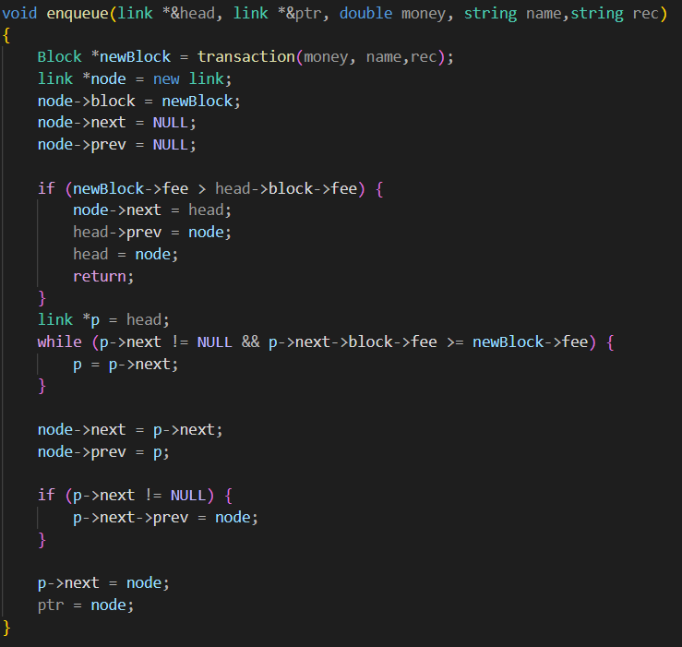
Fig 1. enqueue function of priority queue
- Graph:
This graph structure models the transaction network within the blockchain by representing each user as a node and each payment as a directional link between them. It efficiently tracks all transfers of value by recording the transaction amount and confirmation status along every connection, creating a clear and searchable record of fund movement across the entire system. This allows for the analysis of transaction pathways, verification of payment histories, and oversight of network activity.
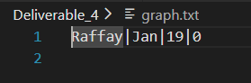
Fig 2. Figure shows sender, receiver, transaction amount respectively
- Struct:
The Block struct is a fundamental component of the blockchain, designed to store essential data for each block. It includes:
- index: An integer that represents the block's position in the blockchain.
- nonce: A string used in the mining process to generate a valid hash.
- hash: A string that stores the cryptographic hash of the block, ensuring data integrity.
- fee: A double that represents the transaction fee associated with the block, used for prioritizing transactions in the queue.
- *next and *prev: Pointers of Block type to point to next and previous blocks in a blockchain.
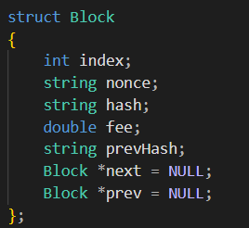Fig 3. struct use for a block
- Hashmaps:
The unordered_map stores key_value pair that links complex wallet addresses to readable usernames. It loads all user data into memory so that when you enter a recipient’s wallet address, the system can instantly look up who owns it. This allows the program to verify the recipient immediately without having to slow down and search through the entire text file every time a transaction is made.
- Stacks:
A stack is implemented to track users' most recent transaction amounts for quick retrieval. Using a linked-list structure (stack_base and history_stack), it supports push and seetop operations in O(1) time. This allows the "View recent transacted amount" menu option to instantly display the latest transaction, enhancing the user experience. To ensure reliability, the implementation should allocate new nodes for each push and properly manage memory.
- Binary Search Tree:
A Binary Search Tree organizes mined blocks by transaction fee within the miner dashboard. Blocks are inserted (bstinsert) based on fee value and displayed via in-order traversal (bsttraversal), showing higher-fee blocks first. While efficient on average (O(log n) insertion), the tree is unbalanced and can degrade with sorted data. For consistent performance, a balanced tree structure is recommended in future iterations.
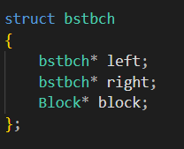 Fig 4. declaration of a node for binary search tree
- Miscellaneous:
- Class:
The project uses a class structure to encapsulate the blockchain's functionality, including methods for inserting blocks and managing the chain.
- Sorting:
The priority queue implementation includes a sorting mechanism that maintains transactions in descending order of fees, ensuring that higher fee transactions are processed first.
- File Handling:
The project includes file I/O operations for persisting the blockchain and user data. Functions like update_money and mining_gift handle reading from and writing to files to maintain user balances and transaction records.
- User Authentication:
Basic user authentication is implemented through file-based user accounts. The transaction function verifies user balances before processing transactions, ensuring that users have sufficient funds.
- Pointers:
The implementation makes extensive use of pointers for dynamic memory management and to maintain the linked list structure of the blockchain. This includes creating and managing blocks and links between them.
- Performance analysis:
Initially, computational overhead was high, so multiple optimizations were incorporated. Below is a detailed performance analysis of key functions and procedures after optimization:
- Miner Brute Force Loop Optimization:
Initially, the mining algorithm used a brute force loop starting from i=0 to 9000, converting each i to a hexadecimal hash via a custom hashmaker function i.e. O(1) per iteration. This resulted in unnecessary operations, as the valid nonce range is 1000-9000.
After that, loop’s start point was shifted to i=1000, aligning it with the valid nonce range.
Before this implementation, minimum operations were 1000 while maximum were 9001. After this, minimum operations shifted to 1 while maximum got to 8000. Thus, this optimization resulted in a significant reduction in wasted iterations, improving mining speed and CPU utilization.
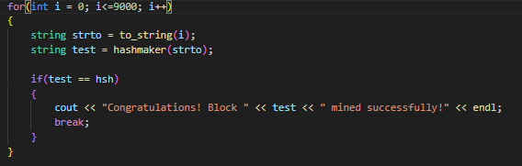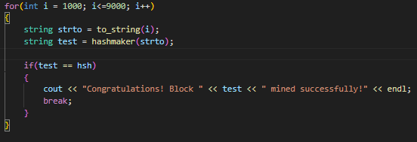
Fig 5. Loop before Fig 6. Loop after
- Username Availability Check:
During user signup, a linear search was performed on login.txt to check for existing usernames, resulting in O(n) complexity where n is the number of registered users.
To optimise this, the system attempts to open a file named after the entered username so if the file exists, the username is taken otherwise it is available.
Initially, minimum operations could be 1 and maximum n and after implementation minimum and maximum both got to 1.
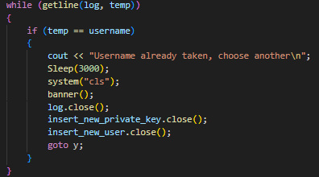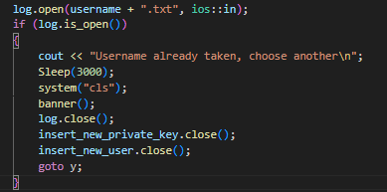
Fig 7. Code snippet for searching before Fig 8. Code snippet for searching after
This eliminated scalability bottlenecks as user count grows.
- Priority Queue Implementation:
A priority queue was implemented using insertion sort in descending order to ensure transactions with the highest fees are mined first. Each new node required traversal to find its correct position.
After optimization, an early-exit condition was added: if a new transaction has a higher fee than the current head, it becomes the new head immediately, leveraging the queue’s sorted nature.
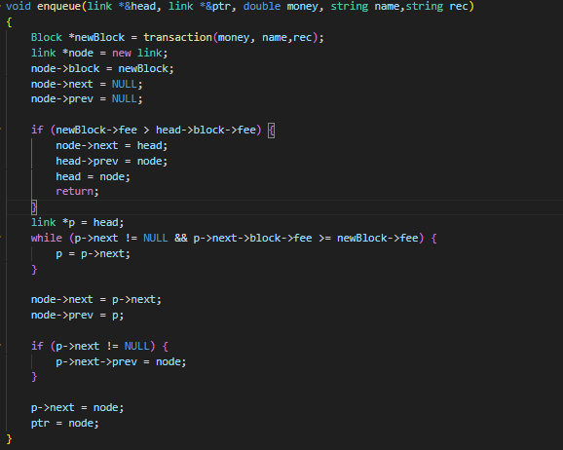
Fig 9. Optimized code snippet for priority queue implementation
This reduced average insertion time, especially for high-fee transactions, improving miner selection speed.
- Challenges faced & solutions:
- We experienced frequent Git merge conflicts when team members edited the same files without pulling the latest changes first.
- Integrating new data structures like the priority queue required careful testing to avoid breaking the existing mining logic.
- Managing pointers in the blockchain's linked list was tricky and occasionally led to memory access errors during traversal.
- Future improvements:
Following future improvements should be made:
- Replace the basic hexadecimal hash function with SHA-256 to ensure cryptographic security. This provides collision resistance and deterministic hashing. Encrypt sensitive data (private keys, transaction details) using AES-256 before file storage for enhanced security.
- Implement automatic blockchain serialization to a file after each mining operation. On startup, load the existing chain to maintain continuity across sessions. This allows miners to resume work, users to verify historical transactions, and the system to simulate long-running networks.
- Implement dynamic fee calculation based on network congestion. Higher fees during peak times incentivize faster mining, while lower fees during idle periods encourage participation, mirroring real blockchain economics.
- The graph structure will be fully integrated with mining validation, automatically updating the confirmed status of all transactions within a newly mined block from "Pending" to "Confirmed." Additionally, transaction flow analytics will be implemented directly within the graph to visually detect suspicious patterns, such as circular payments or unusually high-frequency transfers between users, for enhanced fraud monitoring.
- Add transaction nonce fields to prevent double-spending and replay attacks. Validate sender balance before accepting transactions into the queue.
- Replace console-based UI with a graphical interface showing real-time blockchain visualization, transaction status, and miner statistics for better user experience.
- Conclusion:
This project let us build a small, working version of a blockchain from the ground up. We used simple programming parts like lists and queues to create a system where users can make transactions and miners can securely add them to a permanent record. While our model is basic, it successfully shows how the main ideas of a real blockchain work. It was a great way to learn by building, and it gives us a strong starting point to add more features in the future.

